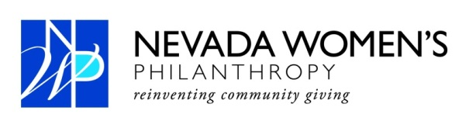
For Immediate Release Contact: Anne Kellogg
(702) 595-4985
kelloggal@gmail.com

Carrie Henderson Named President of Nevada Women’s Philanthropy
Las Vegas (Nov. 14, 2011) - Nevada Women’s Philanthropy (NWP) has named Carrie Henderson president, Nazanin Ford vice president, Kelly Petersen treasurer and Tami Hance secretary.
Henderson established BEST Agency and serves as the company’s president. She is a founding member of NWP which was created in 2006. She has chaired the education and membership committees and served on the grant screening committee for the past two years. She was NWP vice president for the 2011 grant cycle.
“It has been an honor to be a part of NWP since its inception, “ President Henderson said. “The evolution of our organization continues to inspire me with what a group of individuals can create with a common vision to make a difference in our community.”
In October, NWP voted to grant $325,000 to Salvation Army of Southern Nevada so it can rehabilitate a 12,500 square-foot building that serves as its emergency overnight shelter and in-take facility on its Owens Avenue campus. When complete the Salvation Army of Southern Nevada-NWP Rehabilitation Shelter Refurbishment will include 20 more beds in its emergency shelter which translates into 7,300 additional bed nights for the homeless. Community Counseling Center of Southern Nevada, this year’s runner-up, received the $30,000 NWP Founder’s Grant.
Past grant recipients include the Rape Crisis Center, NWP Signs of Hope Counseling Center ($350,000); 2009 Legal Aid Center of Southern Nevada, NWP Children’s Attorneys Project ($325,000); 2008 Public Education Foundation, Empowerment Schools Program ($450,000); 2007 Greater Las Vegas After-School All-Stars, Roundy Elementary School ($320,000). The inaugural grant was awarded to Foundation for an Independent Tomorrow. It created the NWP Employment Project with $180,000. Three Square and Lied Discovery Children’s Museum are NWP Founder’s Grant recipients.
NWP has gifted $1.9 million to non-profits in Southern Nevada since it was created in 2006.
About NWP
The Nevada Women's Philanthropy (NWP) is a member driven, pooled fund, large impact grant making organization established to address the needs of the greater Las Vegas community. NWP’s membership consists of philanthropically motivated women, united by a powerful desire to address emerging issues facing our community in the areas of arts, education, environment, social services, and health. For more information, please visit www.nevadawomensphilanthropy.org.
###

